Gift Aid Declaration
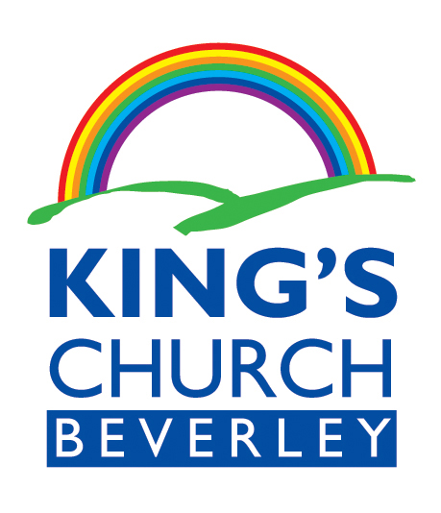

Please treat

The enclosed gift of £…………
as a Gift Aid donation

OR

All gifts of money that I make today, in the previous 4 years and in the future to King’s Church Beverley as Gift Aid Donations. Amount given today

£ …………….
I am a uk taxpayer and understand that if I pay less income tax and/or capital gains tax than the amount of gift aid claimed on all my donations in that tax year it is my responsibility to pay any difference

Donor’s details

Title ______ Initial(s) ______Surname____________________________

Home Address _______________________________________________

____________________________________________________________

Postcode _________________________ Date ______________________

Signature _____________________________

King’s Church Beverley will reclaim 25p of tax on every £1 that you give.

This does not affect your personal tax position.

Please notify the charity if you;

Want to cancel this declaration
Change your name or home address
No longer pay sufficient tax on your income and/or capital gains

If you pay income tax at the higher rate or additional rate and want to receive the additional tax relief due to you, you must include all your Gift Aid donations on your Self-Assessment tax return or ask HM Revenue and Customs to adjust your tax code.

King’s Church Beverley is a registered charity, Number 1128073
.
For more info see www.kingschurchbeverley.org or ring 01482 870490

King’s Church Beverley, Swinemoor Lane, Beverley, HU17 0JX

